**The Dream Catcher**

Our product is a sleep quality sensor and can help to improve your quality of sleep. To come up with our idea, we researched about how sleep can affect the quality of your physical and mental wellbeing.

We decided that we would make a product that can detect the air quality in your room (e.g., CO2 levels, temperature, and humidity). It should also be able to play sound, like white noise, so that you can use them to help get to sleep. The Pi can give you a crucial rundown of why you are feeling more tired during the day, with a quick overlay showing up on the raspberry pi touchscreen. The product will help show you what you need to change in your sleeping environment and what is possibly causing you to get bad sleep, ultimately causing bad mood and fatigue during the day.

The raspberry pi will help, because often people will be left confused about why there are feeling tired during the day, even if they got a full night's sleep. If you just place out machine on your bedside table, it can take information in while you sleep, and when you wake up the screen would show you easy to read rundown of all the data the raspberry pi got. This can provide insightful info like tossing and turning, or loud sounds in your room or different air levels (e.g., CO2, air temperature etc) in your room that could cause you to wake up or not have good sleep during the night. It will then tell you how to prevent these issues from happening and lead to a more fulfilled night sleep and daily life.

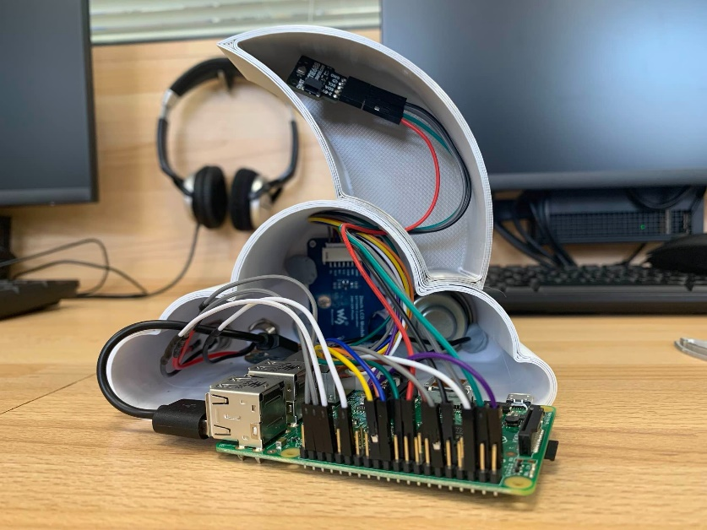

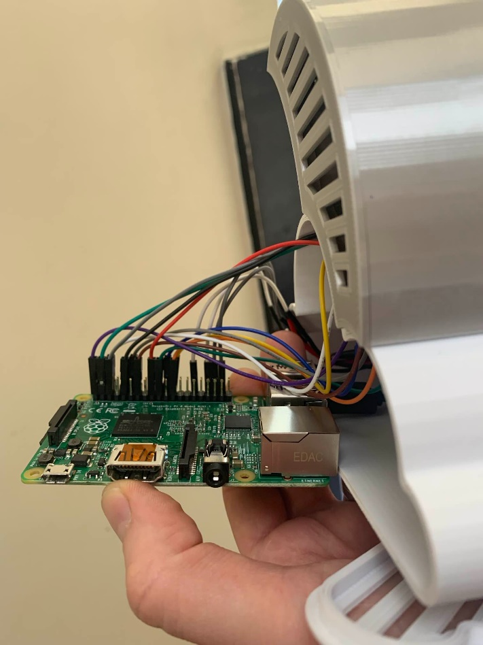

The Raspberry Pi

The insides of the Dream Catcher

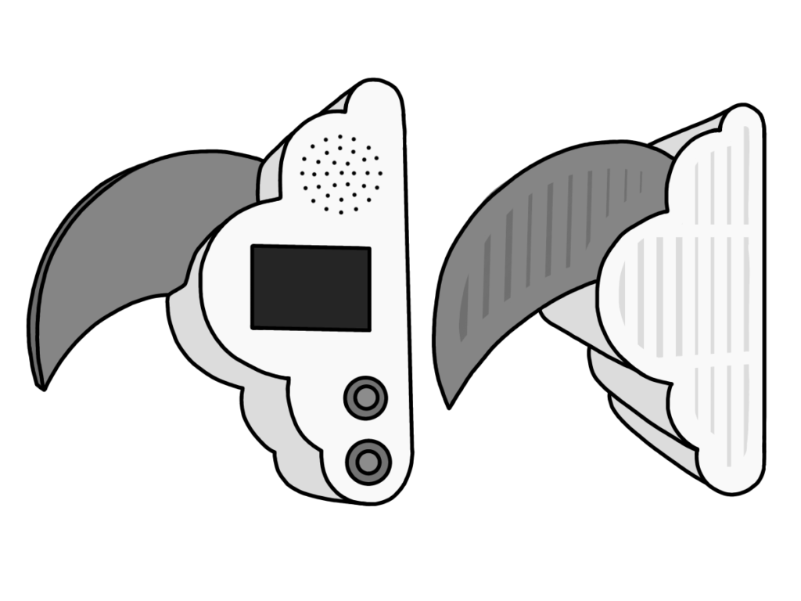To make our product, we first got our raspberry pi and wired up all our components. We had to wire in our sound sensor, air quality sensor, speaker and screen. We also had to figure out where we were going to store our pi and make it look aesthetically pleasing at the same time. We found a moon design on the internet, and we liked the theme, so we came up with several designs and ended up on a moon with a cloud, with spaces to see our screen and speaker, and fit the pi inside the cloud. We wanted the design to be calming and have a reference to sleep, so we chose the moon because of the nighttime and sleep. Then we 3d printed out our design. We then had to code our raspberry pi using python (again!). We found this very challenging as we still don’t know a lot about writing python code because it is very difficult. We used lots of different websites to try help us to research our code.

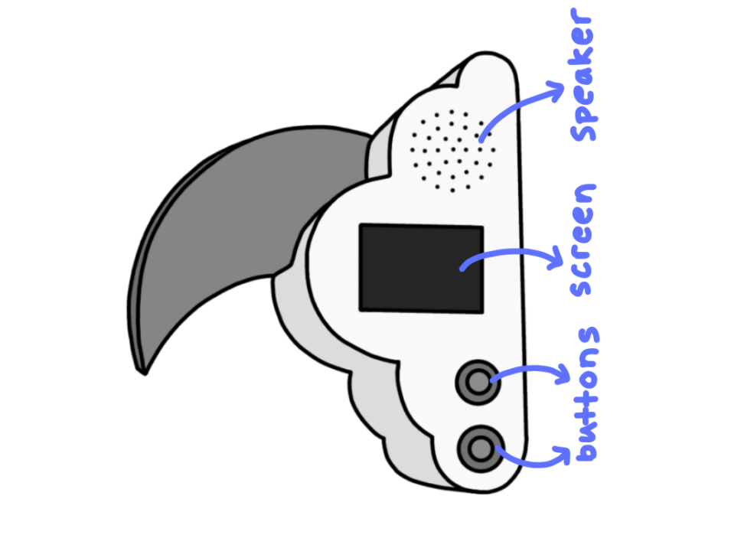

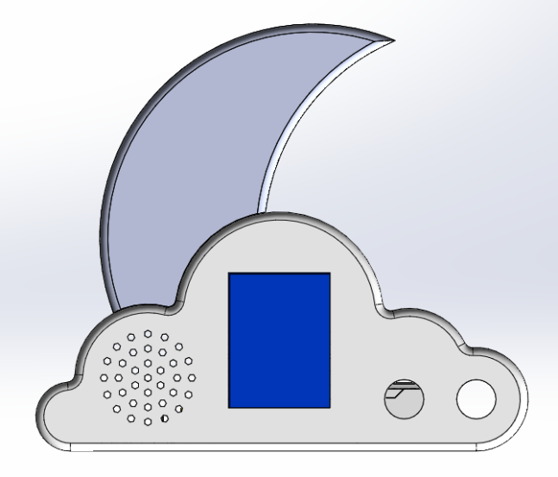

Our CAD designs

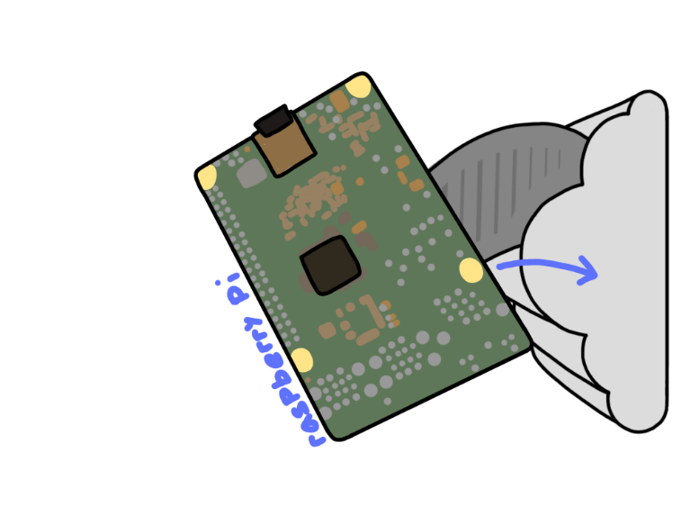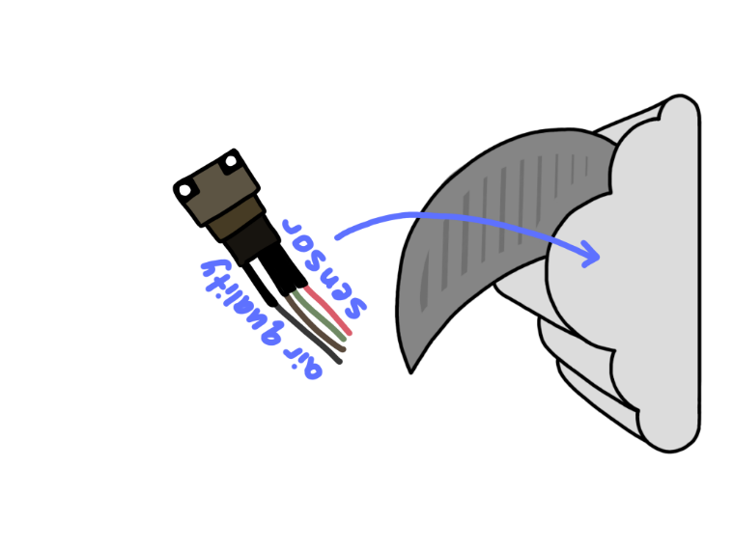We struggled a lot with wiring up all our different components onto our raspberry pi and making them all fit. In the end, we managed to get them all wired in and working perfectly! The other thing we found the most difficult was coding (as mentioned above!). We did a lot of research about coding python and how to write it correctly.

When a button is pressed, the screen will show either a thumbs up or thumbs down, depending on the quality of the air in your room. This shows you that if you slept bad, it might have been because of the air quality, and you need to change your environment. When the other button is pressed, sounds will play from the speaker holes. The audio is only a few seconds long, as this is just a prototype.



In the future, we would love our screen to be able to display words about what is the things that is making the air in your room bad (e.g., temperature, humidity, CO2), and it would tell you what you need to change. We would also make our speaker be able to play more noises and for a longer duration of time.

